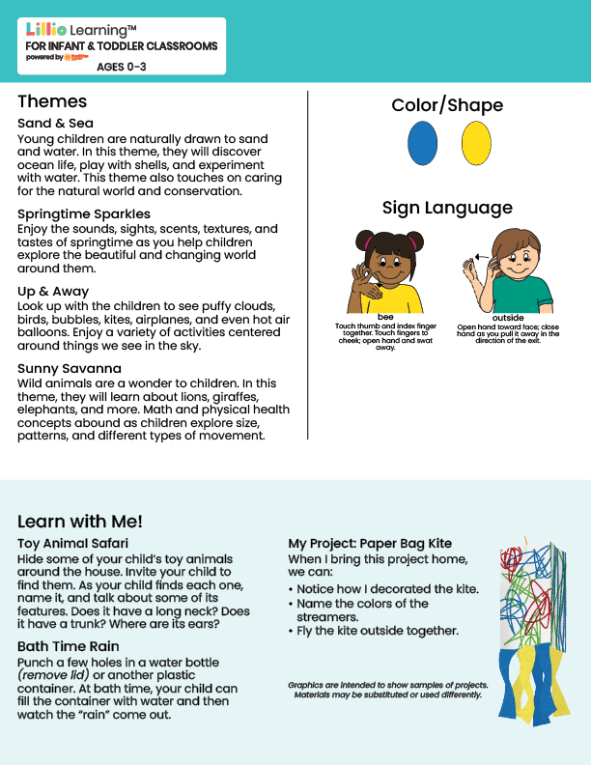
Mar/Apr 2026
NEWSLETTER
Add Name or Logo Here

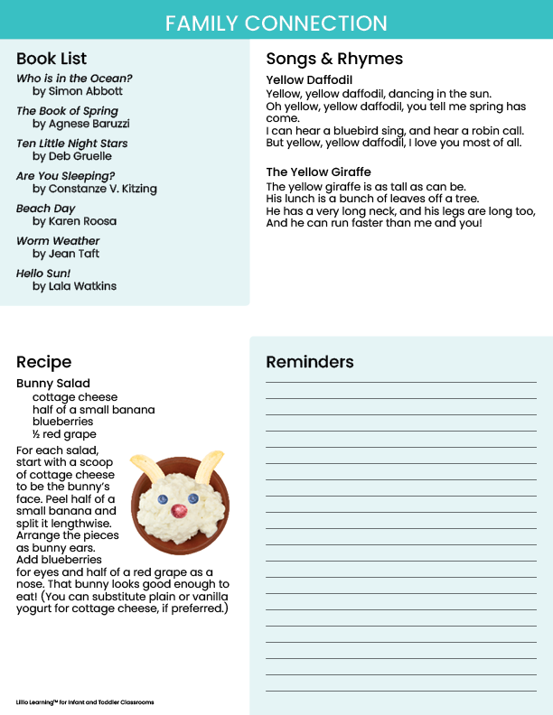

Add Notes Here

